The V4 population supports Ukrainian refugees with some reservations

The perception of Ukrainian refugees among the Visegrad Group member states is mostly positive. However, the picture is different in Slovakia. While a majority of citizens in Czechia, Hungary, and Poland take a favourable view towards people fleeing the war in Ukraine, 52% of people in Slovakia see their presence as negative, a new GLOBSEC report shows.
The poll revealed widespread support for hosting Ukrainian refugees in Poland, Hungary, and Czechia, with only 11%, 15%, and 25% of people, respectively, perceiving the presence of Ukrainian refugees in their countries negatively.
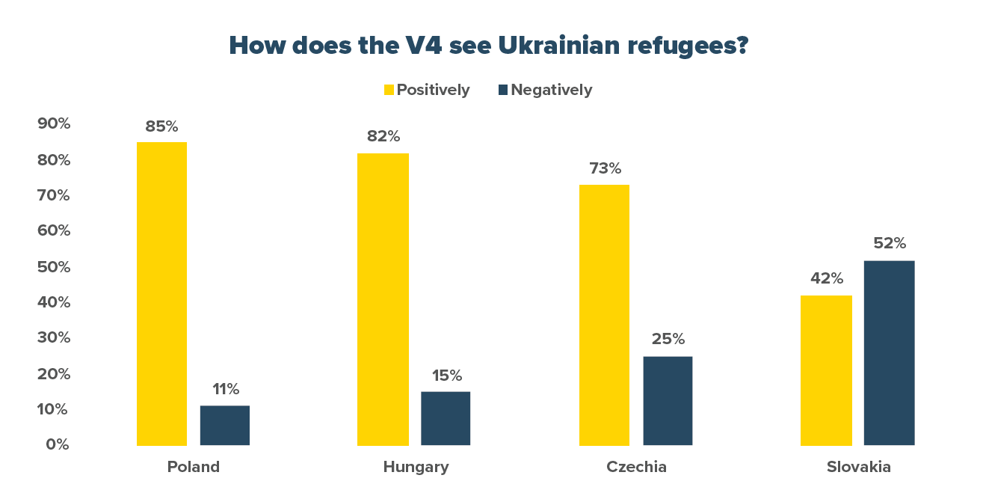
Figure 1. How do you feel about your country hosting Ukrainian refugees?
For the sake of simplicity, we merged the proportion of ‘very’/‘rather’ positive and ‘very’/‘rather’ negative answers. The remaining % are do not knows.
"One of the key drivers of negative perceptions are the concerns of the host populations fearing negative impacts of refugee aid on their own economic situation. This is reflected in the opinion on what sort of support the refugees should receive," explained one of the report's authors, Patrik Szicherle, Research Fellow for the Democracy & Resilience Center at GLOBSEC.
The majority of V4 citizens see free language courses as the most and free or subsidised housing as the least favourable form of refugee assistance. Comparing all four countries, Slovaks seem to be the strictest, as 68% of them would like to see "support" provided to Ukrainians slashed from current levels. Slovaks also stand out as the only populace where a majority believe those fleeing Ukraine should not gain access to free healthcare and, along with Hungarians, voice discontent with refugees taking unwanted jobs.
"Party politics is another decisive factor affecting perceptions of people fleeing the war. The voters of parties that promulgate hostile rhetoric against refugees are considerably more likely to view the presence of Ukrainians unfavourably," concluded the report's co-author, Jana Kazaz, Research Fellow for the Democracy & Resilience Center at GLOBSEC.
Such an unfavourable image of Ukrainians is also more prevalent among people who use personal communication channels and social media as a source of news. The latter is a go-to source for more than 20% of people in all V4 countries and a frequent amplifier of negative messages about Ukrainian refugees. Comparing the four countries, Hungarians are the least likely to use personal communications and social media as news sources, while Slovaks are the most likely.
Who people blame for the war matters too. Those claiming either Ukraine or the US/NATO were responsible for the war in Ukraine are far more likely to perceive Ukrainian refugees negatively. The report shows that Slovaks are the most divided on this issue and the least likely to say Russia bears responsibility – this partly explains why they harbour the most negative attitudes towards refugees fleeing their eastern neighbour.
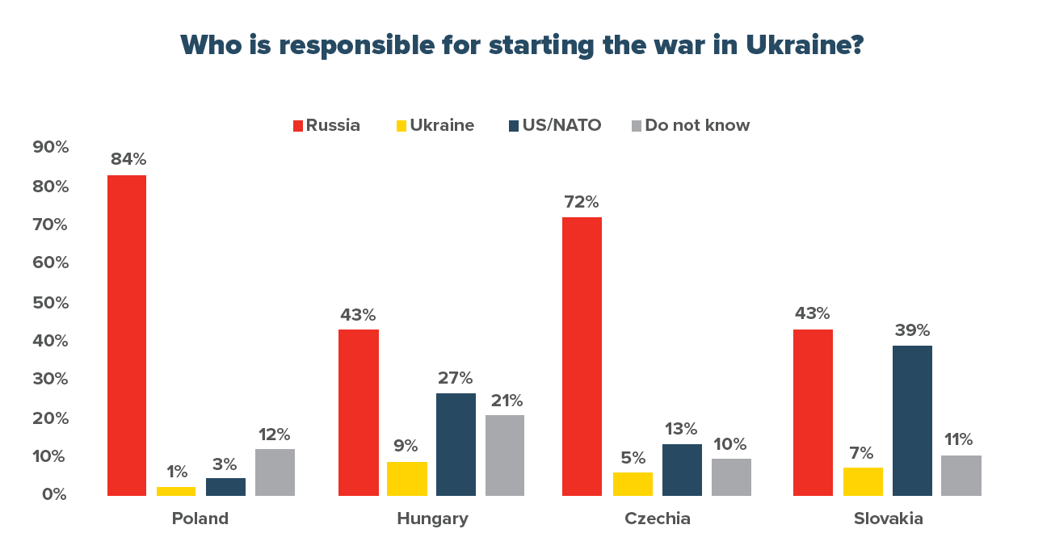Figure 2. The proportion of respondents blaming Russia, Ukraine, the US and NATO for the war, and the proportion of those who did not know or did not answer the question.
As shown by the report, perceptions and opinions are not formed only by individuals' own experiences; they are influenced by various external factors, including "personal stories" often taken out of context or generalised with respect to an entire group of Ukrainian refugees. This is why political voices and organisations lending their assistance to Ukrainians fleeing the war must remain vigilant if they wish to maintain the relatively positive view of the refugees coming to the V4 countries to seek shelter and help.
Read the full report to learn more about how the V4 member states can foster a positive image of Ukrainian refugees at www.globsec.org.
Vladimir Putin's unprovoked attack on Ukraine has caused widespread destruction and prompted substantial refugee flows to the V4 countries. According to official numbers, as of November 2022, about 1.5 million refugees are registered in Poland, 458,000 in Czechia, 100,000 in Slovakia, and around 31,000 in Hungary.
The poll for the report was conducted by the FOCUS agency and its partners with a representative sample of 1000 people in each of the V4 countries. The survey probed the views of respondents on a range of issues, including their attitudes towards hosting refugees, refugee assistance, threat perceptions, and the attribution of blame for the conflict.
About GLOBSEC:
GLOBSEC is a global think-tank based in Bratislava committed to enhancing security, prosperity and sustainability in Europe and throughout the world. It is an independent, non-partisan, non-governmental organisation. Its mission is to influence the future by generating new ideas and solutions for a better and safer world. To this goal contributes the annual GLOBSEC Bratislava Forum, one of the leading global security conferences. GLOBSEC also organises the annual GLOBSEC Tatra Summit, a conference that provides the opportunity for experts to have fruitful political discussions on the future of Europe.
Media contact: Olívia Strapeková; olivia.strapekova@globsec.org

