Aleksandar Karatosho has extensive experience from national & international civil society organizations. In the past, he was a scholar of the Konrad Adenauer Foundation, a member of the Student Parliament at the University of Ss. Cyril and Methodius & a Secretary of People to People International – Skopje Community Chapter. Currently, Aleksandar is one of the Young European Ambassadors from the Western Balkans, an Ambassador of the European Student Think Tank, and a member of European Democracy Youth Network & the Euro-Atlantic Council of Macedonia. Additionally, Aleksandar is the President of the non-profit civil society organization Youth Empowerment Association and a Director of the Karatosho Foundation, which is working on active citizenship, environmental protection & cultural heritage.

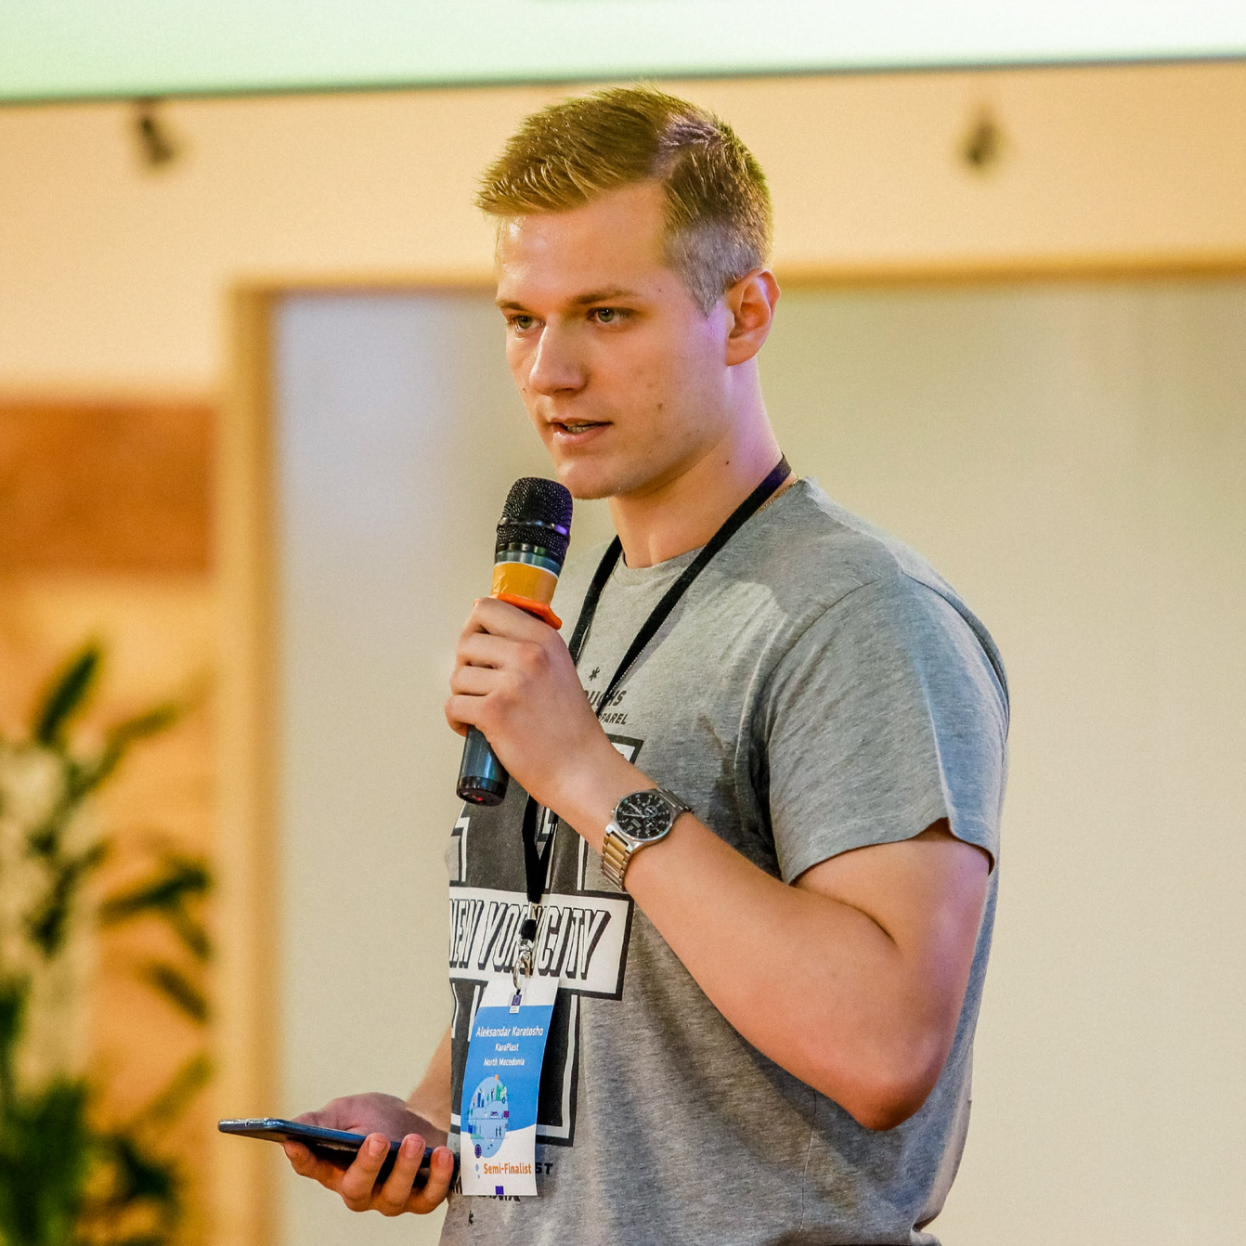

aleksandarkaratosho@hotmail.com

